GUI Konzept

Ablauf Schreens
LoadingScreen
MainMenuScreen
HighscoreInsertScreen
HighscoreScreen
CreditsScreen
OptionScreen
GameScreen
Start

Grobdesign

LoadingScreen

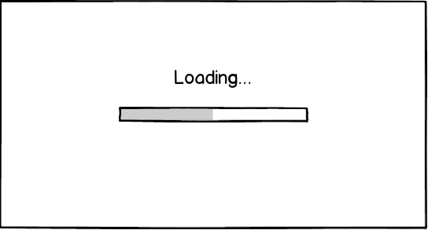
MainMenuScreen
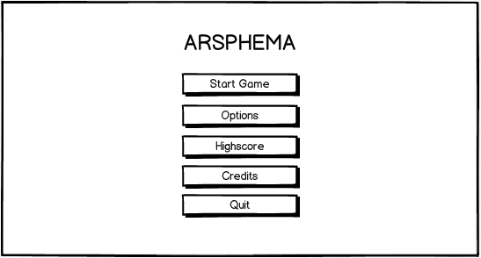

HighscoreScreen
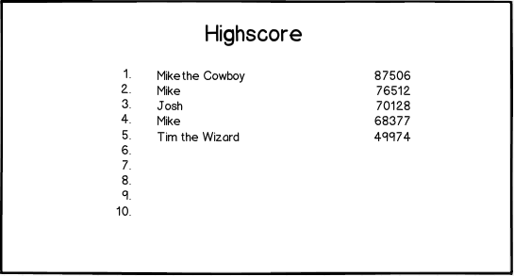

HighscoreInsertScreen
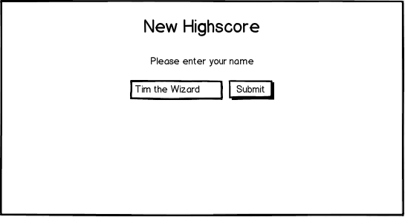

OptionScreen
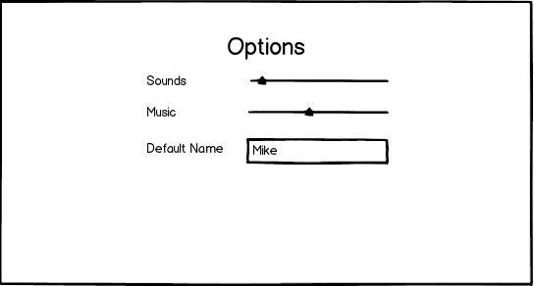

CreditScreen
